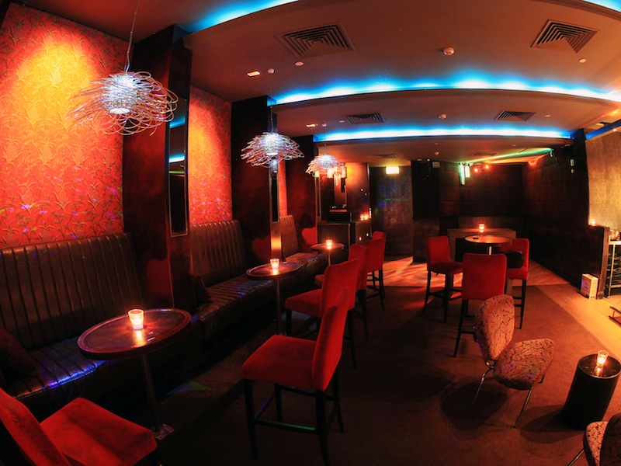 | 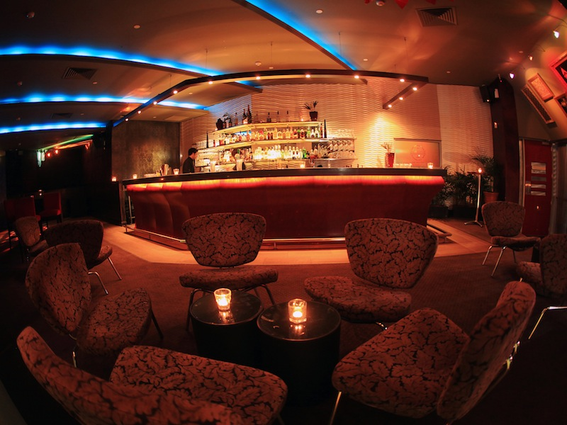  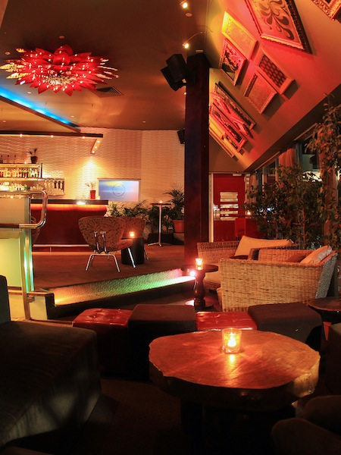

The Avenue Function Information Pack

The Avenue is an intimate comfortable cocktail club located in the heart of Claremont, which makes it the perfect venue for your next corporate function or special occasion.

The Avenue has a capacity of 100 people and is ideal for all types of occasions. With delicious food and beverages on offer and warm furniture to compliment, there is no reason to have your next function anywhere else.

For further information or to make a booking please contact our function coordinator on the number provided or alternatively send an email to functions@clubbayview.com.

Kind Regards,

Nikki J Musca
Venue Manager
The Avenue
Ph: (08) 9425 5223
E: nikki@clubbayview.com

Bookings
All bookings can be confirmed and secured by making full payment of the venue hire charge. Once payment has been received and the confirmation agreement form filled out, you will receive a booking confirmation receipt via email. Unfortunately we are unable to hold dates without the signed agreement form and full venue hire payment.

Please note: Cancellation of your function will result in loss of your venue hire fee. See the terms and conditions for full details.

Venue Hire
Venue hire is charged at $500 for up to 4 hours, a $100 is charged for each additional hour there after. Venue hire includes exclusive use of the Avenue Night Club for your arranged time and all in house AV equipment.

Bar Options
The Avenue offers an ever changing fresh cocktail list suited for all. From twists on classics to $10 specials and Avenue originals. As well as this our friendly bar staff are trained to accommodate all flavors on the spot. The bar also offers a full range of spirits; tap beer and an extensive variety of wine and champagne.

There is a $1,000 minimum spend over the bar which can be reached by using a bar tab, on consumption bar or cash bar.

Bar Tabs
- Select your limit (i.e.; $2,000).
- Select the drinks you would like to be available to your guests (i.e.; Beer, wine, soft drinks, bottom and/or top shelf spirits).
- Our bar staff will remind you of the tabs progression throughout the night and it may be increased if you choose.
- Your bar tab account will need to be settled before leaving the venue.

Personal Bar Tabs
- Our bartenders require a credit card and a drivers license to set up a personal bar tab.
- A tab card will be issued to you and will need to be presented for the purchase of all drinks for this tab.
- Ask our staff for regular updates of the running total of the tab.

Cash Bar
- Yourself and your guests pay for drinks with individual payments throughout the night as you would a public bar.

On Consumption Bar
- No bar limit amount.
- Select the drinks you would like to be available to your guests (i.e.; Beer, wine, soft drinks, bottom and/or top shelf spirits).
- Our bar staff will remind you of the consumption progression throughout the night.
- Your consumption bar account will need to be settled before leaving the venue.

Catering
All catering for functions needs to ordered and supplied by the Avenue. The Avenue offers various catering options to suit all budgets. We pride ourselves in only offering the freshest produce to our clients and have various caterers at our disposal. All food is served cocktail style and is offered to your guests by The Avenue service staff, the food is served on platters and is charged on a per head basis offering 7 pieces per person.
Menus are a set selection of hot and cold canapés and are set priced. Please see our catering options listed below.

Canapé option 1 $15 per person – Minimum 40 guests

- Gourmet mini party pies / sausage rolls / spring rolls (v) / chicken satay / samosas (v) and dipping sauce - hot
Canapé option 2 $22 per person – Minimum 40 guests
- Antipasto platters – On bar tables for arrival

      - Assorted sushi with soy and ginger (v) - cold
      - Thai beer rice paper rolls with glass noodles, crunchy Asian vegetables, spiced tofu, toasted peanuts with an Asian dipping sauce - cold

      - Authentic Satay chicken skewer -hot
      - Mini beef Shiraz pie with parmesan crust -hot
      - Arancini, verjuice pecorino with sage salt - hot

Canapé option 3 $27.50 per person – Minimum 40 guests

      - Antipasto platters – On bar tables for arrival

      - Pancetta bound chicken and mushroom ballontine, cranberry jam, seeded lavosh -cold
      - Hoisin duck rice paper rolls, with glass noodles, crunch Asian vegetables, toasted peanuts -cold

      - Lamb Moroccan filo cigars, pomegranate pearl and yoghurt dip - hot
      - Katifi bound prawn with wasabi infused mayo - hot
      - Honeyed pumpkin and haloumi cheese filo mini tartlet (v) - hot
      - Salt and pepper pork belly, tamarind glaze - hot

Walk And Fork $6.50 per person – Minimum 40 guests
Choose one choice from the menu selection below.

- Chicken salad, artichoke, croutons, marinated kalamata olive, persillaide - cold
- Thai beef salad, spiced vermicelli noodle, peanut crumble, chili lime dressing - cold

- Vietnamese chicken, coconut rice, coriander, lime dressing – hot
- Creamy penne pasta with semi sundried tomatoes, spinach and parmesan - hot

Walk and fork meals are served in small wonton noodle boxes and are a great way to offer your guests a substantial meal. Walk and fork meals can be ordered in addition to our canapé finger food menus.

Special Occasion Cakes
Please note that you are welcome to bring your own special occasion cake on site, a service charge of $2 per person will be charged to do so. This charge covers cutlery, crockery and napkins.

Decorations
We invite you to decorate the room to suit your function requirements. Please indicate on your application a suitable time to set up your decorations earlier in the day of your function

Please note: We request that you use free standing decorations such as helium balloons, table props etc, as you will be accountable for any damage done to walls or surfaces of the venue. For further information refer to the terms and conditions.

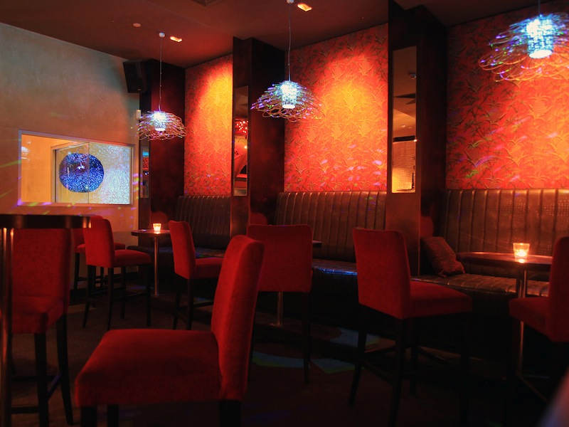
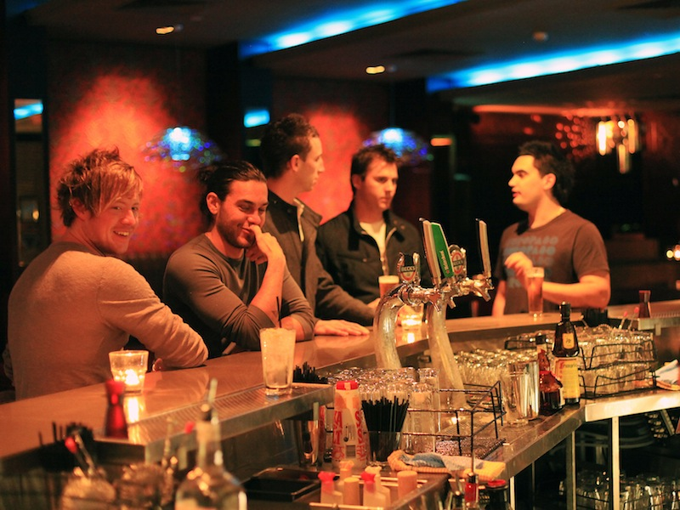

Function Terms and Conditions

Minimum Spend
- The Avenue requires a minimum spend of $1,000 over the bar. If this is not reached you will be required to pay the difference at the conclusion of your function

Venue Hire
- Exclusive use of the venue is charged at $500 for up to 4 hour, $100 is charged for each additional hour there after.

Bookings
- A booking will only be deemed confirmed upon receipt of full payment of the venue hire charge and signed function confirmation agreement. All prices outlined are subject to change at The Avenue without notice.

Payments and Hire
- The venue hire fee is due at the time of booking to secure your function date. The fee is payable by eftpos, cash or credit card (visa, master card, amex or diners).
- A cancellation received (7) days prior to the function will result in 50% of the venue hire being refunded, whilst a cancellation received less than seven (7) days prior to the function date, will result in a forfeit of room hire fees.
- All function charges need to be payed for on completion of the function and before exiting the venue.

Final Details
- Event details including timings, room set-up, and beverage requirements must be forwarded to The Avenue no later than seven (7) days prior to the event. Final numbers are required no later than three (4) days prior to the event.

Damage
- The client/hirer is financially liable for any and all damages to The Avenues fixtures and fittings whether sustained through their own actions, or through the actions of their guests, contractors, sub-contractors including bumping in and out of the venue.

Decorations
- Any styling or theme of the room in any form is at the discretion of management and must be approved in advance.

Insurance and Public Liability
- Under no circumstances will The Avenue take responsibility for any items bought by the client/hirer and their guests into the venue. It is in the client/hirer responsibility to ensure the security of their possession and that of their guests. The Avenue hereby advises the client/hirer that The Avenue will not take responsibility for lawsuits or damages incurred to anyone.

Responsible service of alcohol
- The Avenue supports the responsible service of alcohol. We will not allow and violent, indecent or anti-social behavior on the premises. It is a requirement of the law that intoxicated patrons are removed from the premises. If the majority of guests are deemed to be approaching intoxication, management reserves the right to refuse service and conclude the function at any time. The client/hirer is ultimately responsible for the orderly behavior of their guests and management reserves the right to intervene where deemed fit.

Juveniles
- Persons under the age of 18 are not permitted in The Avenue at any point in time.

Prohibition of food and beverage
- The client/hirer and their guests are not permitted to bring food or beverages on the premises with the exception of celebration cakes, were a per person service fee is charged. All food requirements must be finalized at least seven (7) days prior to function date.

Entering the venue
- The Avenue is a licensed premise; all patrons are required to present photo I.D to enter. Acceptable forms of I.D are limited to CURRENT West Australian Drivers license, CURRENT passport or West Australian Proof of Age card. No other forms of I.D will be accepted.

Dress Standards
- Dress standards in The Avenue always apply. We require males in dress shoes, neat a tidy presentation and no shorts. Fail to meet these standards may result in refusal of entry

IMPORTANT NOTICE: By confirming you’re booking and filling out the agreement form you acknowledge you have read, understood and are agreeing to these terms and conditions. Feel free to contact The Avenue with any query.

Name:
Company: |  | Position Held:
Address:
Email:
Age: |  | Phone:
Event Date: |  | Event Time:
Guest Numbers: |  | Type of Event:
Special Requests:

Venue Hire fee (Required to secure the booking): | $ | Is attached with this form (please circle)
 |  | Yes | No

Method of Venue Hire Payment:(please circle)

Credit Card / Eftpos / Cash / Company Cheque (with cc guarantee)

Please charge the following credit card: |  | Visa MasterCard amex diner’s club
Card Number: / / / . |  | Expiry date: / .
Cardholder’s Name: |  | Signature:

FULL payment must be made to secure the function booking. The Avenue does not extend credit terms. By signing this form I acknowledge and accept the terms and conditions included in this document.

I will in all respects comply with those conditions on acceptance of this application.
Print Name:
Signature: |  | Date:

The Avenue. 20/12 St Quentins Avenue, Claremont, WA, 6010
Ph: (08) 9425 5223
E: functions@clubbayview.com

